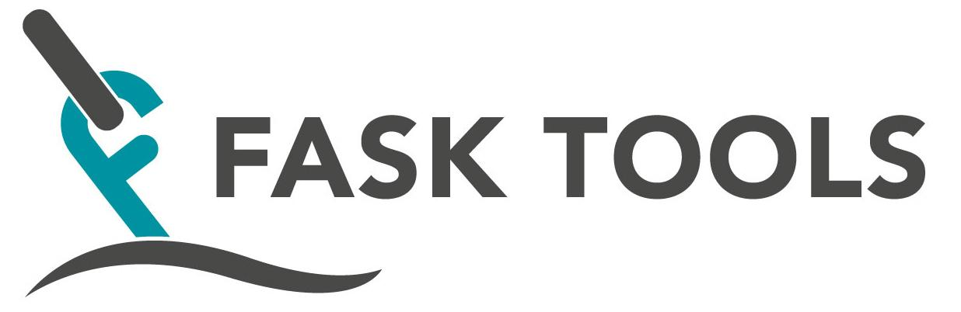

Manual NSP

Manual NSP

Soft Mandrel

- Spare parts
- Maintenance

Punch Device

- Spare parts
- Maintenance

Hydraulic Tool

- Spare parts
- Maintenance

Information

- Hydraulic Tool tested acc. FOR-1982-09-10-1377 Regulations for technical devices. Ref. Norwegian Maritime Directorate.

SM 1200 / Soft Mandrel - Complete tool.

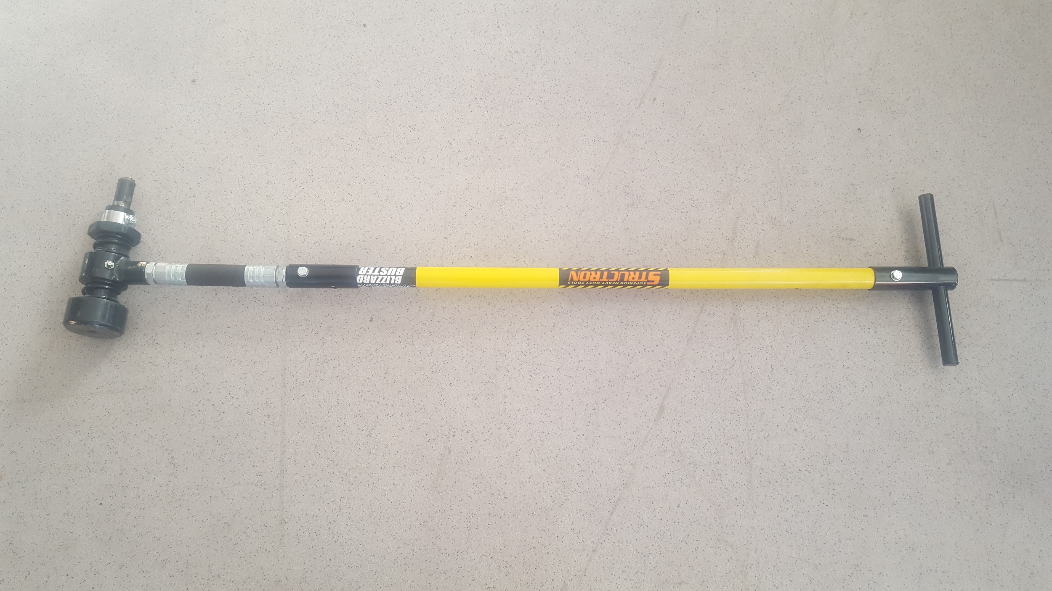

Article no. SM1200

Soft Mandrel - list of spare parts

Article no. | Name | Other
SM 1200 | Soft Mandrel - complete tool
SM 1201-Ex | Mandrel ex (out phased)
SM 1201 | Mandrel with threads and nut ( nut = SM 1207)
SM 1201-01 | Reinforcement ring (for SM1201)
SM 1202 | Outward Bolt L60mm x D24mm
SM 1202-01 | Outward Bolt L85mm x D24mm
SM 1202-02 | Outward Bolt L60mm x D22mm
SM 1202-03 | Outward Bolt L85mm x D 22mm
SM 1202-04 | Outward Bolt L80mm x D36mm (for 120mm kenter etc.)
SM 1202-05 | Outward Bolt L50mm x D36mm (for 120mm kenter etc.)
SM1202-09 | Outward Bolt L85mm x D22mm
SM 1203 | Boss for hose/fiberglass shaft
SM 1204 | Hose - part of shaft
SM 1205 | Feather (2 pce)
SM 1206 Ex | Seegerring (outphased) for SM 1201-Ex
SM 1207 Ex | Stop ring (outphased) for SM 1201-Ex
SM 1207 | Nut (spare stop nut) for SM 1201 Mandrel
SM 1208 | Fiberglass shaft.
SM 1209 | Handle (for Fiberglass shaft)
SM 1202-40 | Pipe clamp for connection fiber shaft/hose

Soft Mandrel - Maintenance

Outward bolt are locked with screw and can by easily be changed out for maintenance or to be replaced with new bolt.

Outward bolt to be checked after use, re-tighten locking screw - avoid rust in connection for outward bolt - keep it clean, tight and lubricated.

Check the fiber shaft for cracks.

Picture below shows the umbraco locking screw open and the Outward bolt outside - this is the SM 1201-Ex .

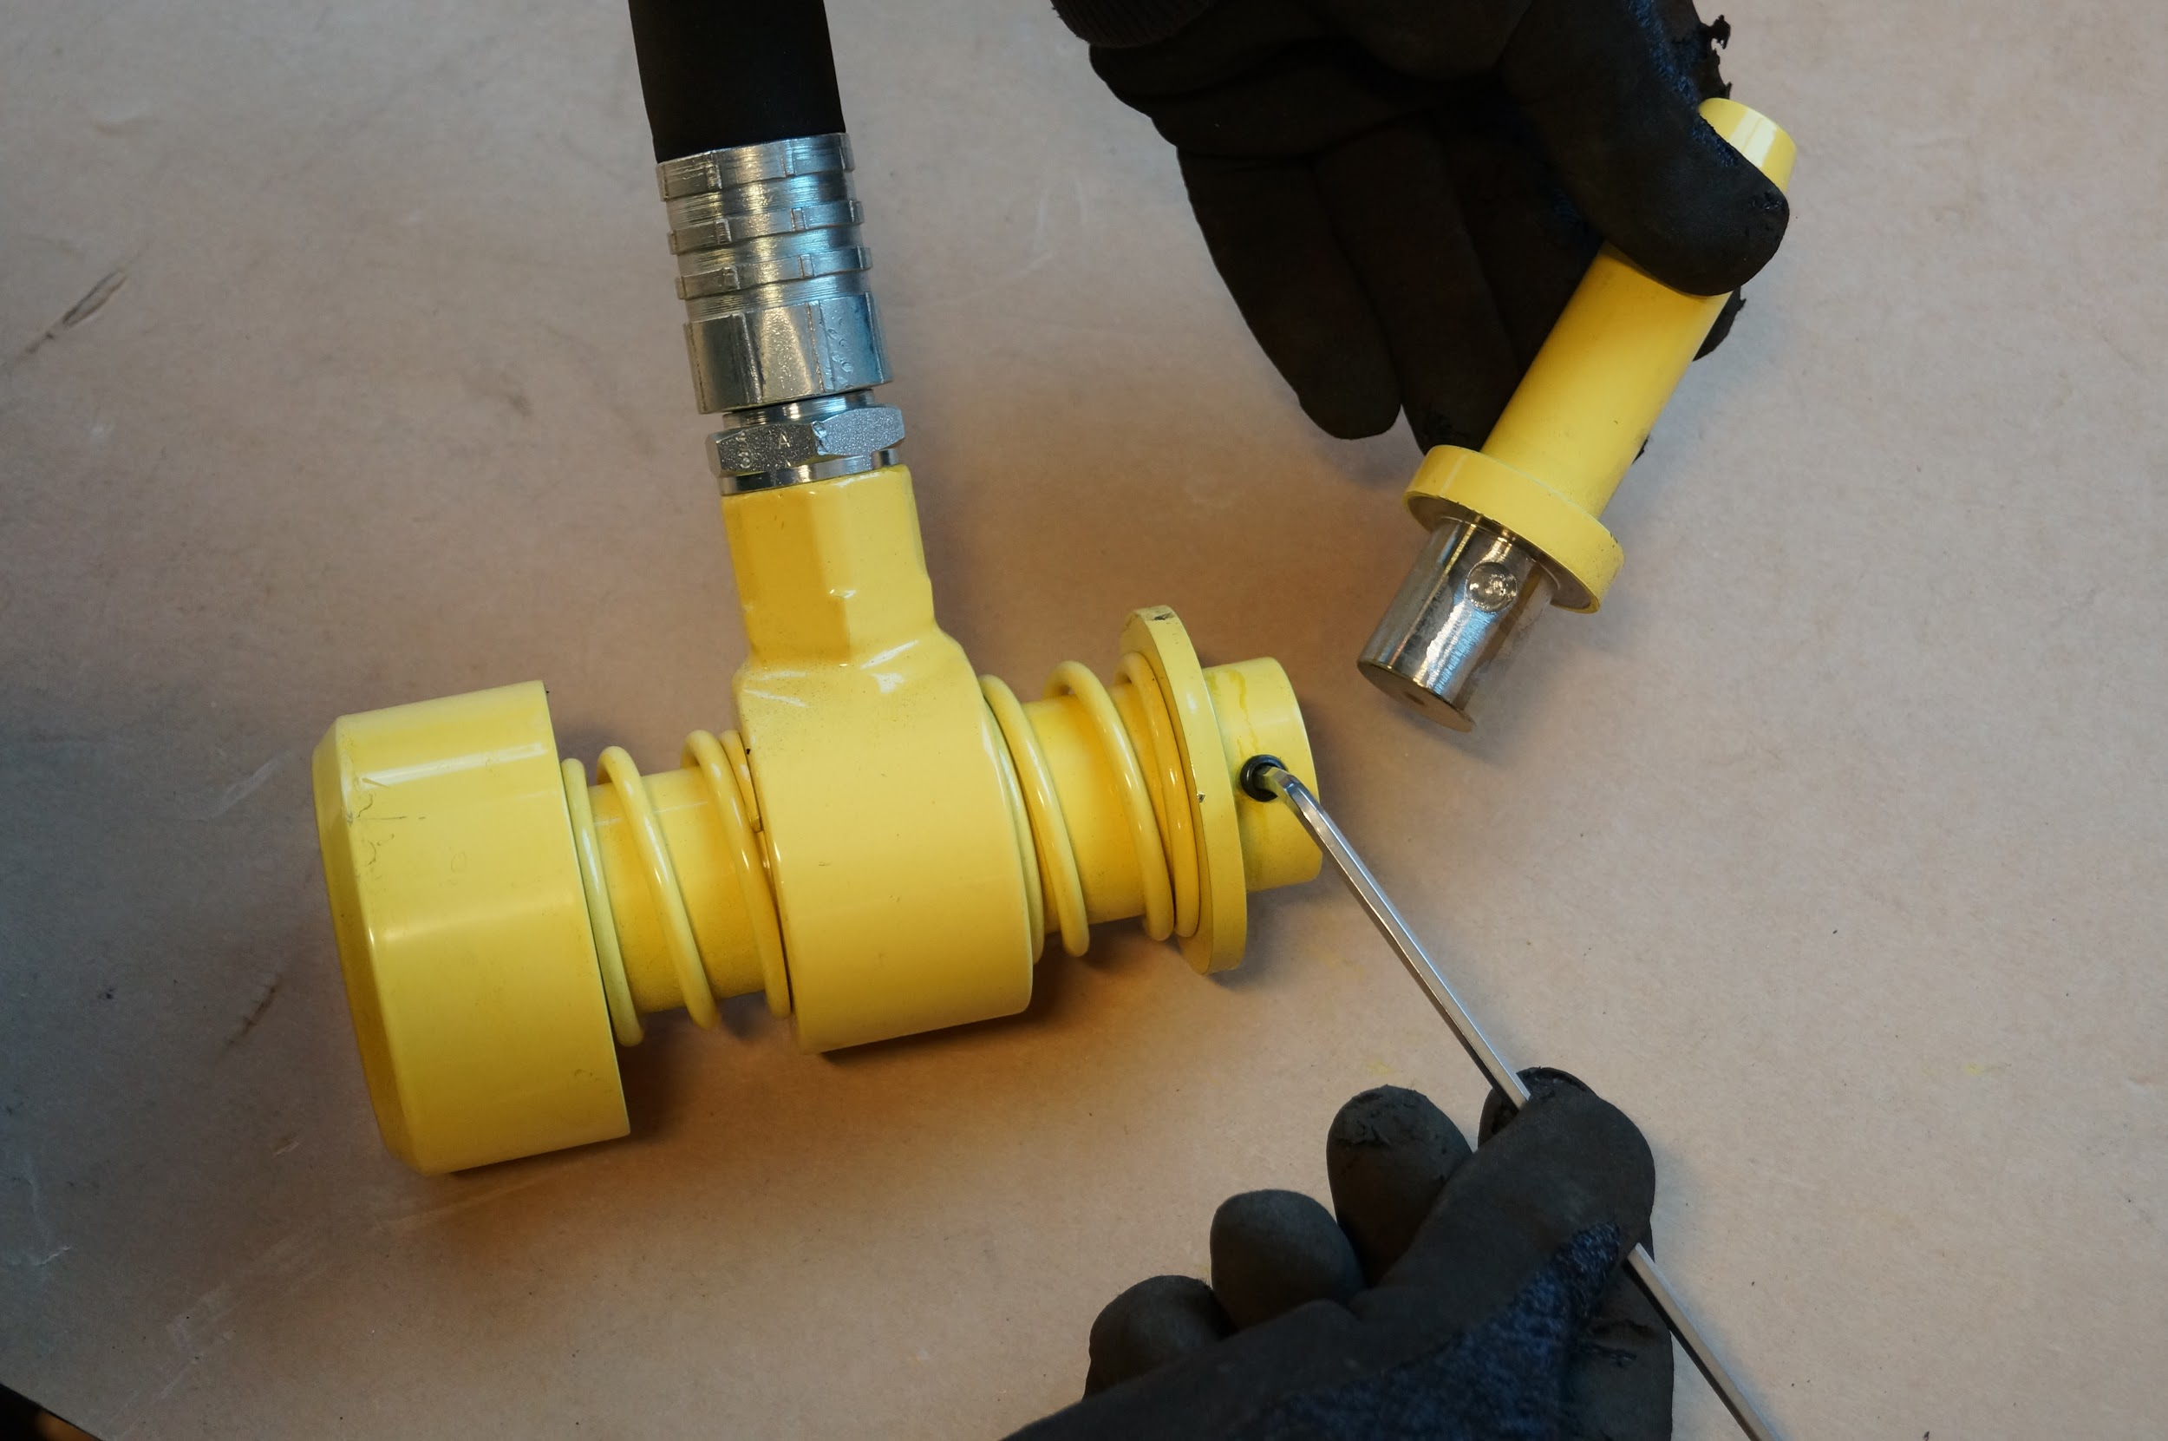

Soft Mandrel

SM 1201 - New version of Mandrel with threads and Nut (SM 1207 - locking nut) instead of Segerring (SM 1206 Ex) and Stop ring (SM 1207 Ex). Outward Bolt has through holes with screw M8 x 45mm for locking in Mandrel

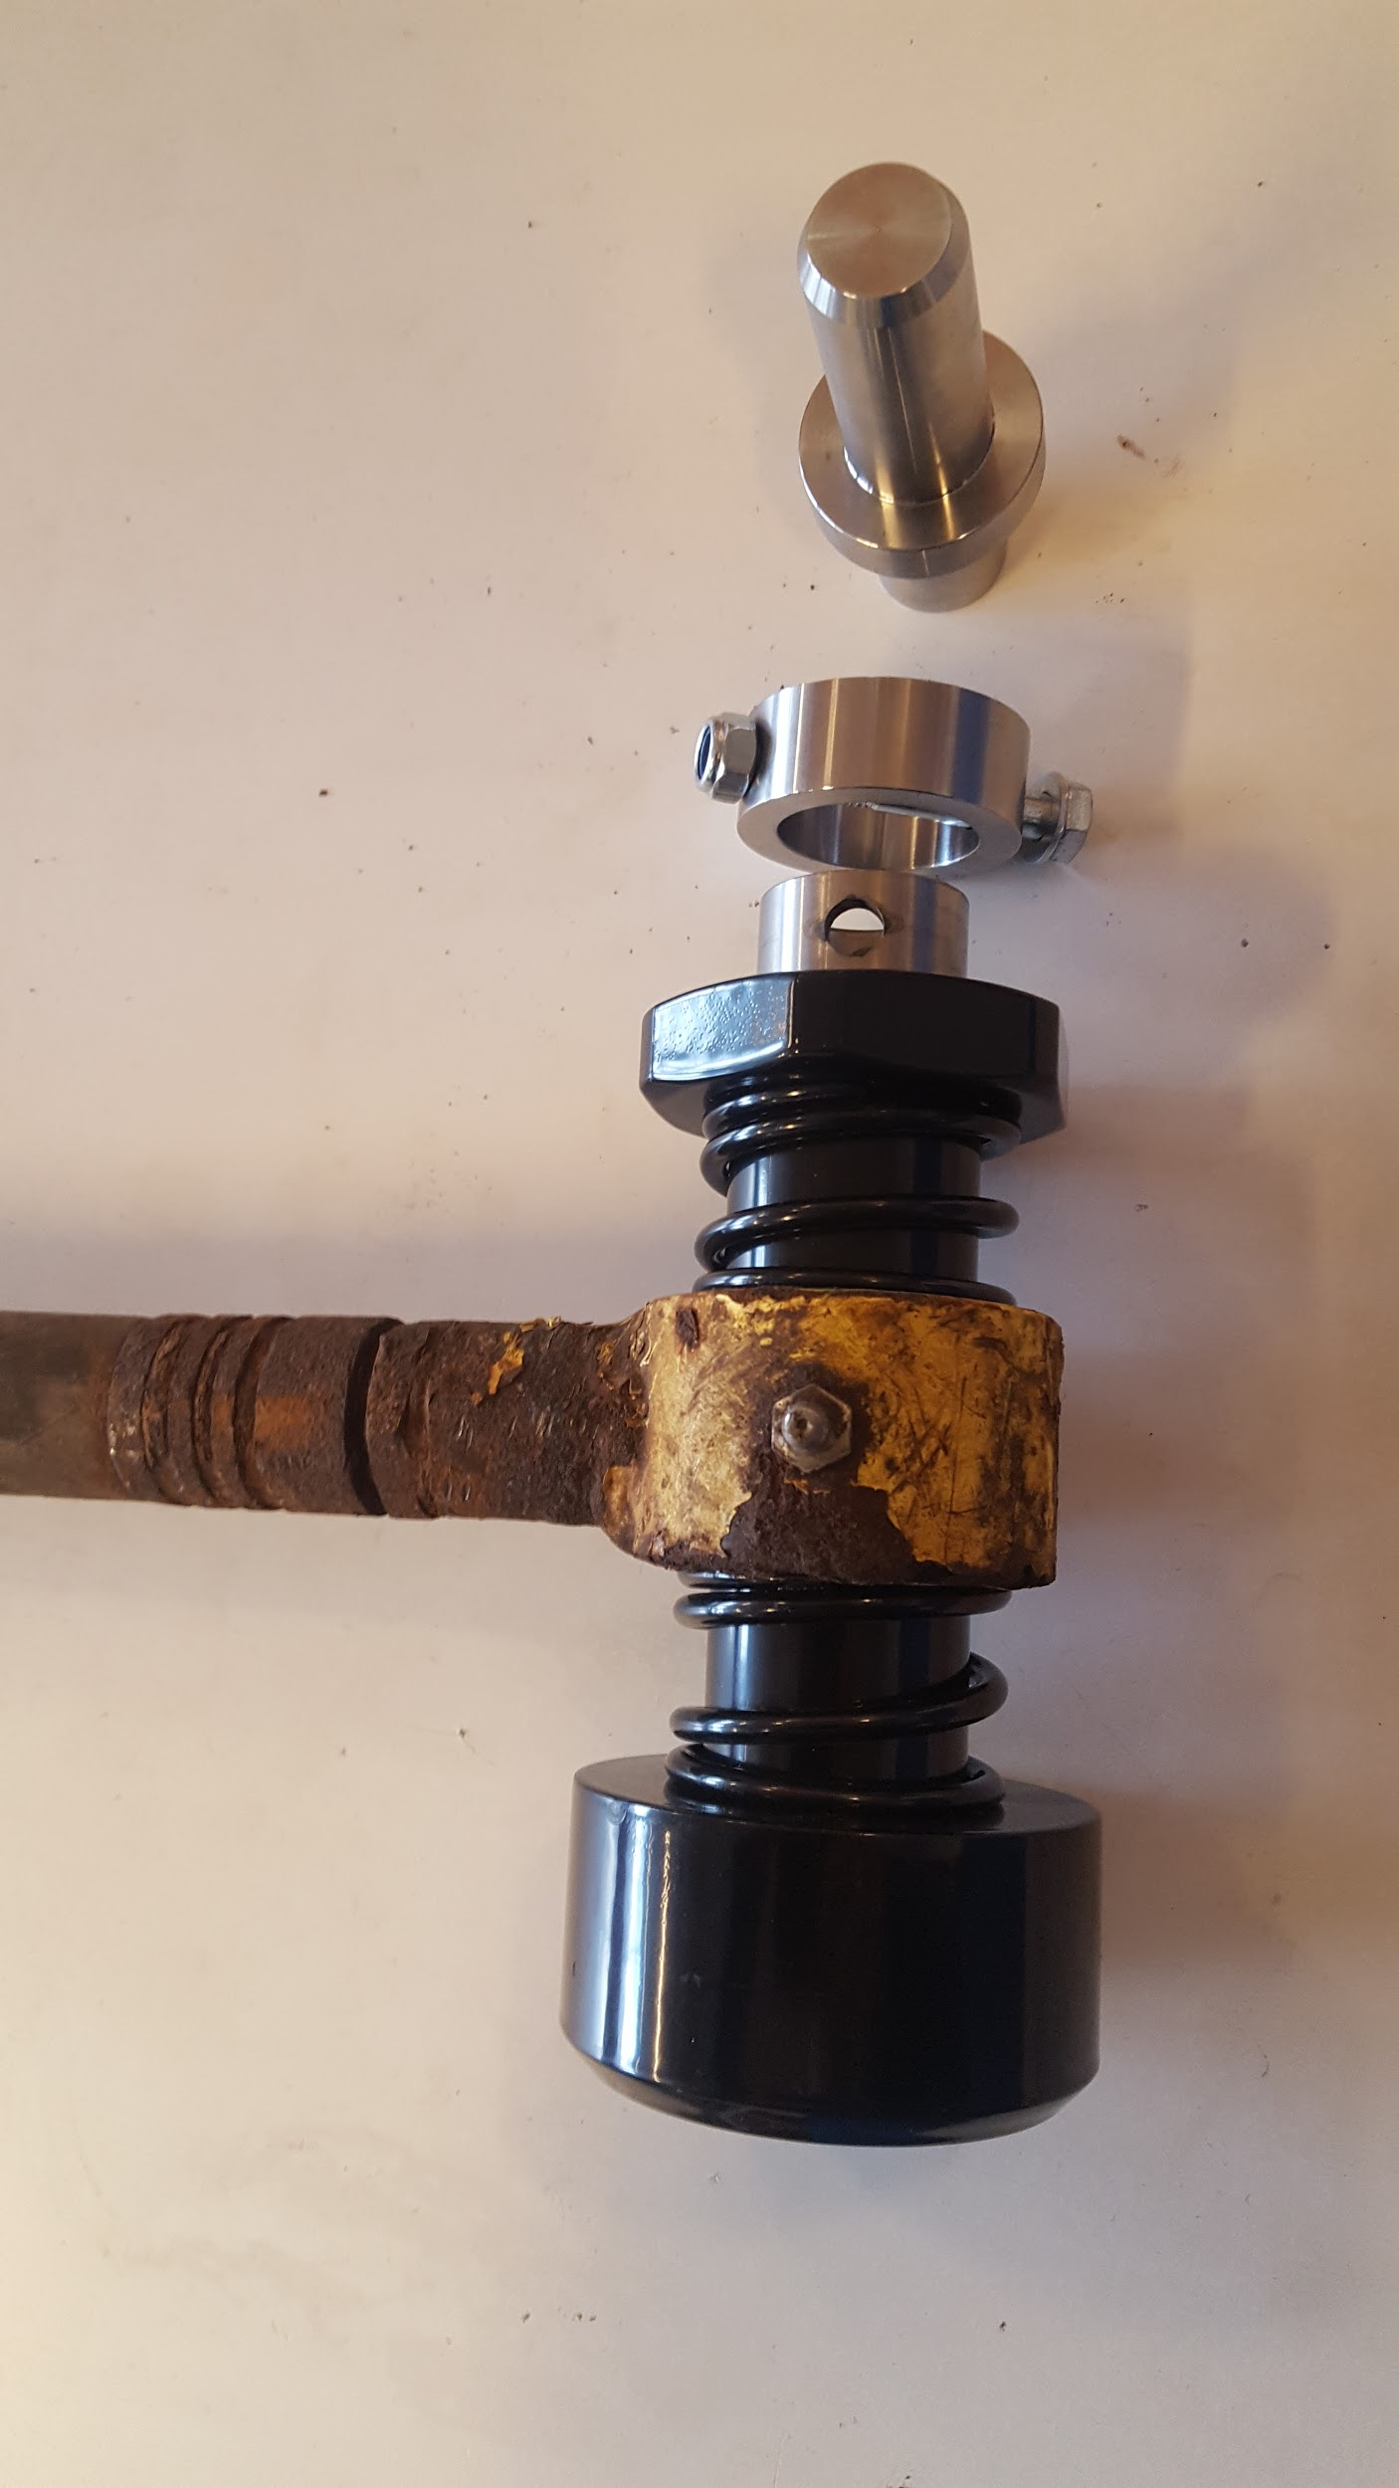

This pictures shows a long time and well used SM that has been maintained with change of the Mandrel. Between the new Mandrel and Outward Bolt - we have the SM1202-01 Reinforcement ring with the M8 locking screw.

Punch Device 76mm

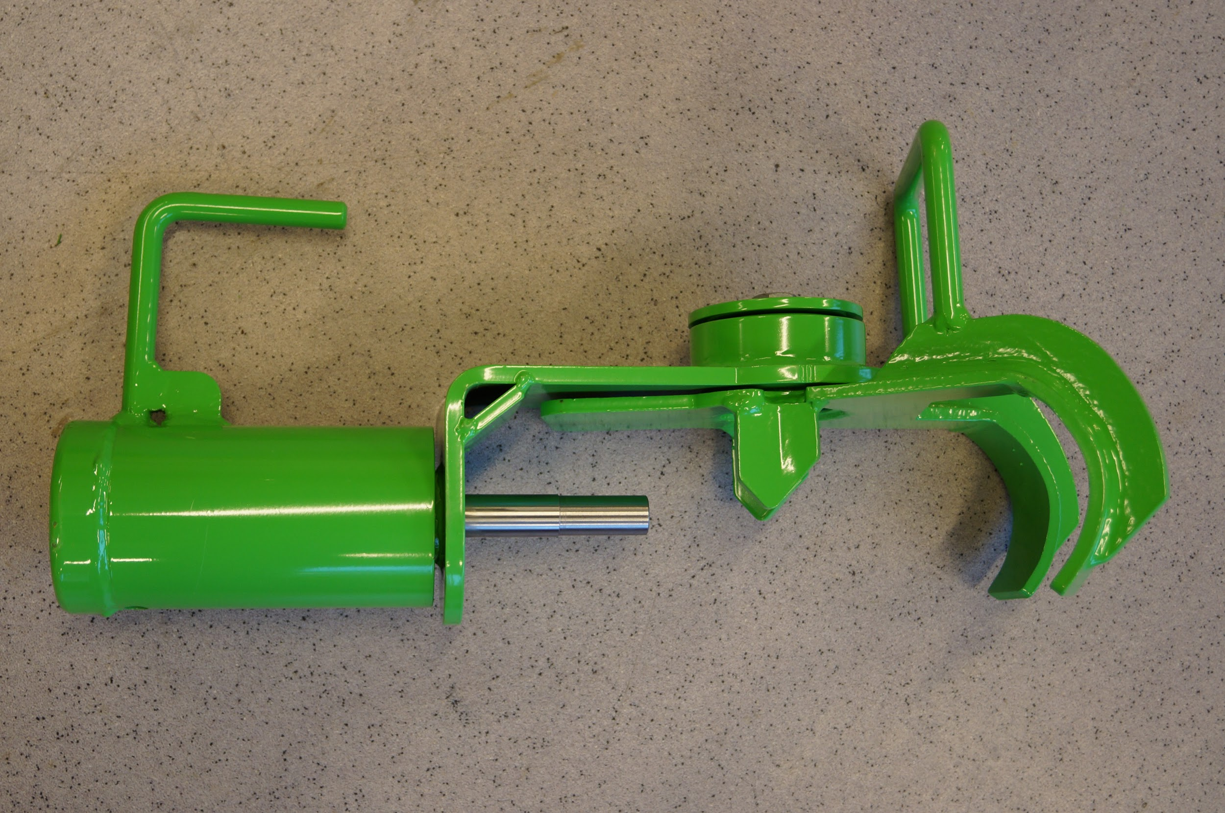

Article no. PD7600 - Complete 76mm Punch Device.

76mm Punch Device assembled and ready for use. Instead of color code (green for 76mm) PD7600 mm are marked with 076.

Punch Device 84mm

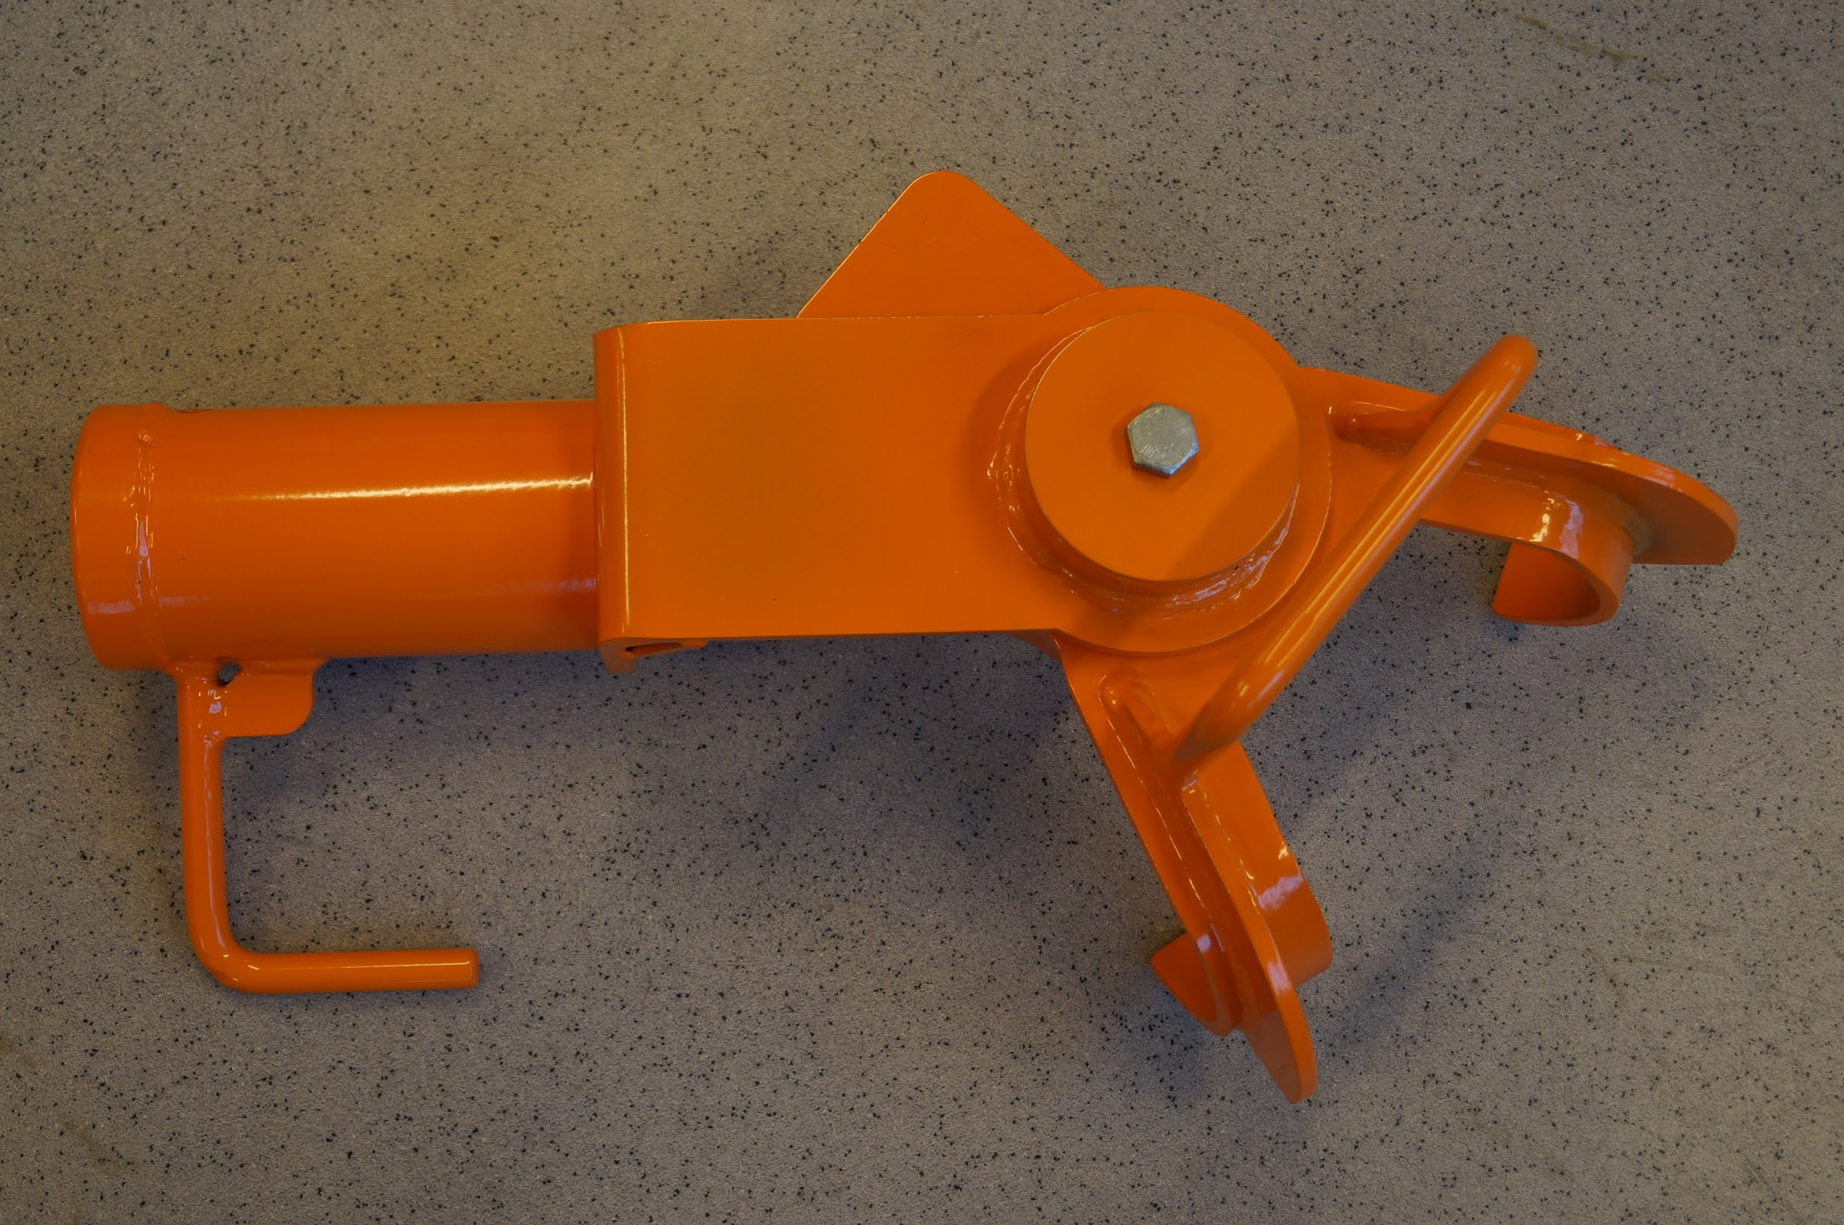

Article no. PD8400 - Complete 84mm Punch Device.

84mm Punch Device assembled and ready for use. Instead of color code (orange for 84mm) PD8400mm are marked with 084.

Punch Device - list of spare parts.

Article no. | Name | Other
PD7600 | Punch Device 76mm - complete tool
PD767600 | Outward Bolt for 76mm
PD768402 | Tube/Punch Pipe (common for 76mm/84mm)
PD768403 | Cover for tube (common for 76mm/84mm)
PD7604 | Swing Arm for 76mm
PD7605 | Bracket for 76mm
PD768406 | Feather (common for 76mm/84mm)
PD768407 | Center Cover
PD768408 | Screw for Center Cover (common)
PD768409 | Seegerring (common)
PD768410 | Umbraco locking screw (common)
PD768411 | Stop ring (common)
PD8400 | Punch Device 84mm - complete tool
PD8404 | Swingarm for 84mm
PD8405 | Bracket for 84mm

Punch Device - maintenance

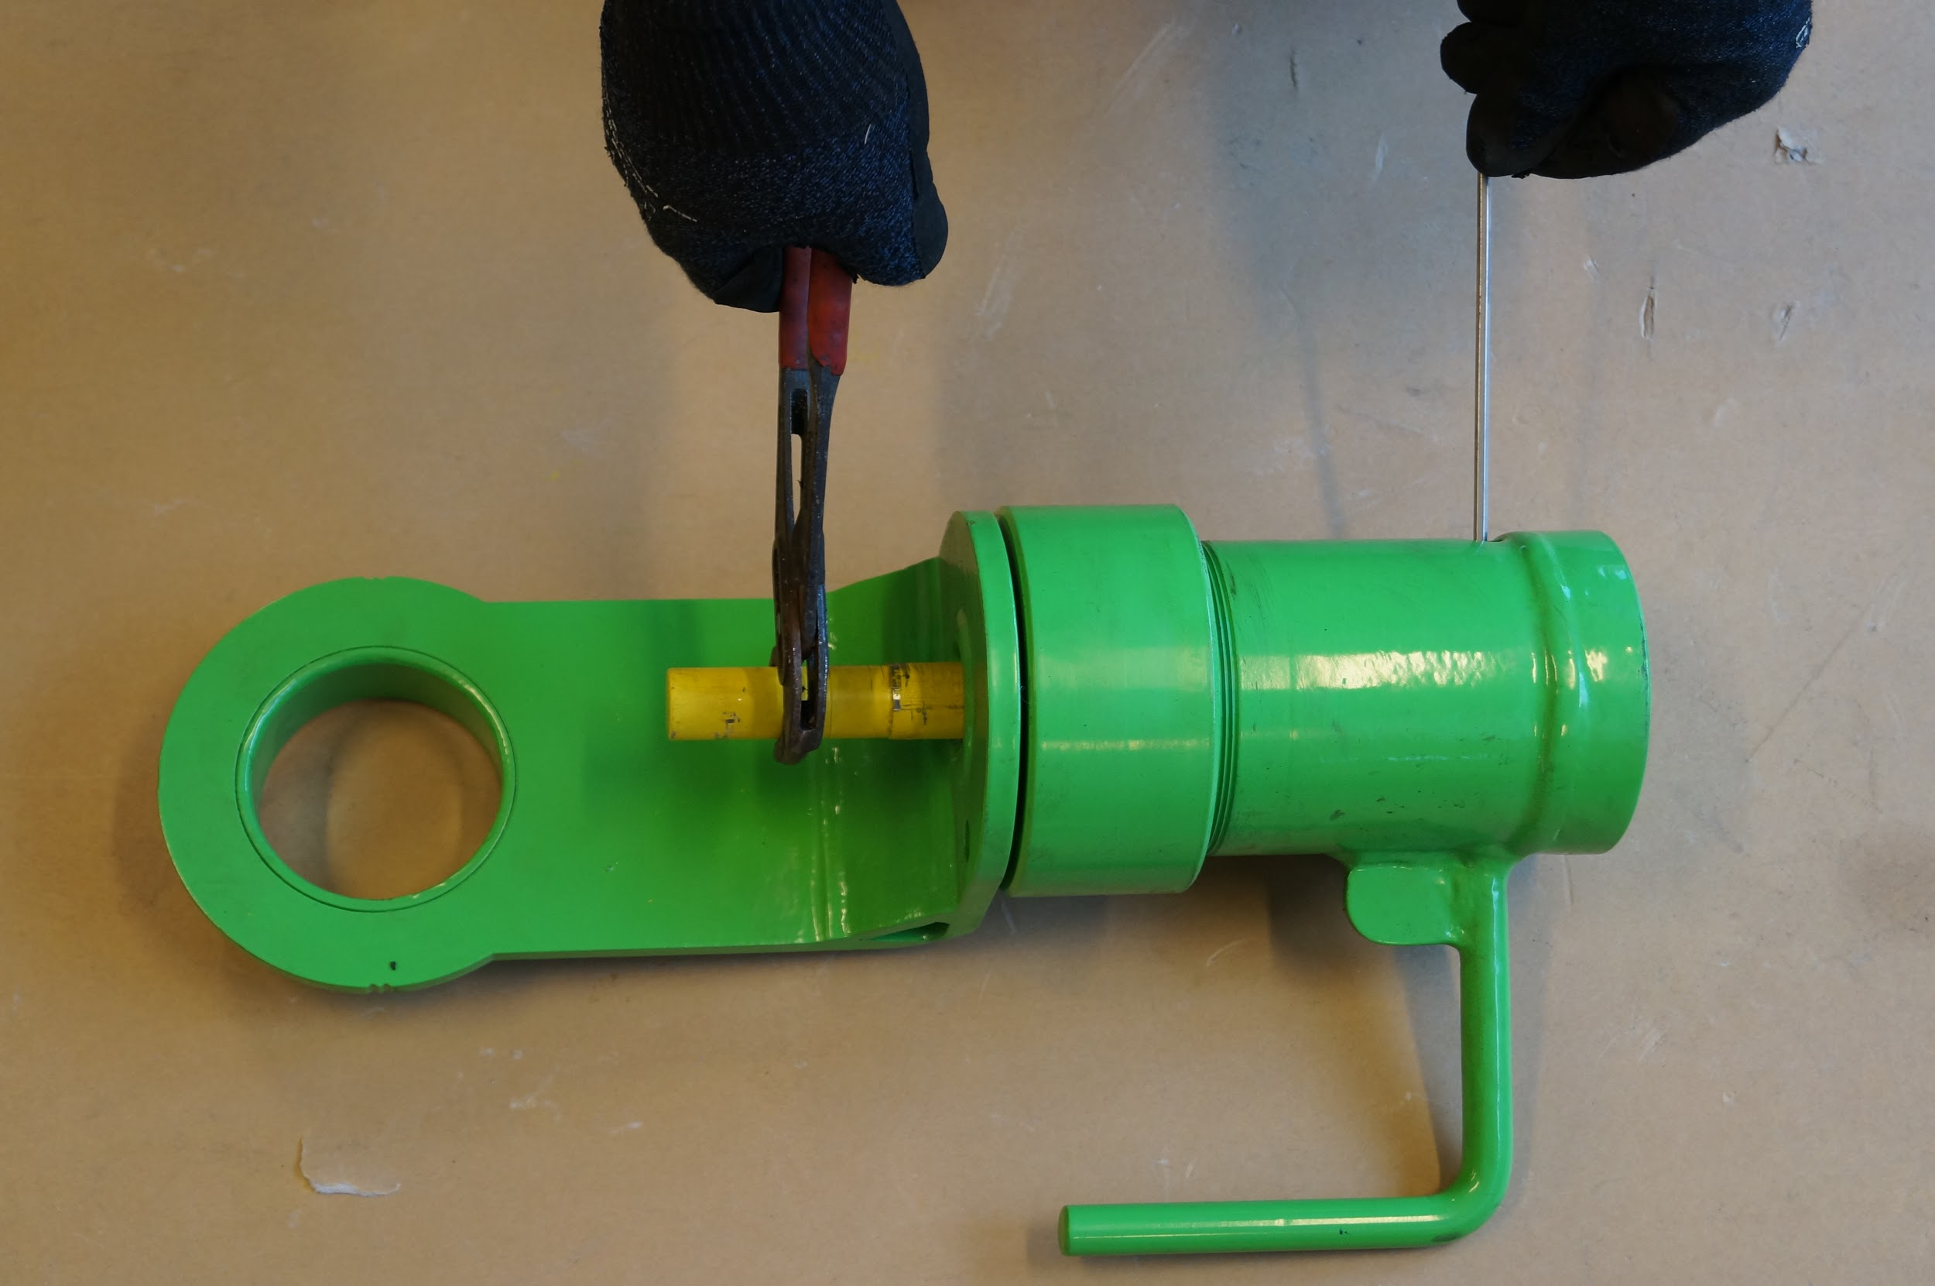

Common for 76mm and 84mm Punch device.

The Outward bolt (yellow) has M24 in the inner end and is locked with a umbraco screw.

Important to take bolt out occasionally for maintenance and lubrication. Remember to screw the Outward Bolt all the way in and lock it with the umbraco screw. Use compressed air to blow clean the threads/clean before inserting the Outward bolt.

Keep the tool clean and lubricated.

Important: Always check the equipment for steel fragments before use.

The Hydraulic Tool

ENERPAC equipment

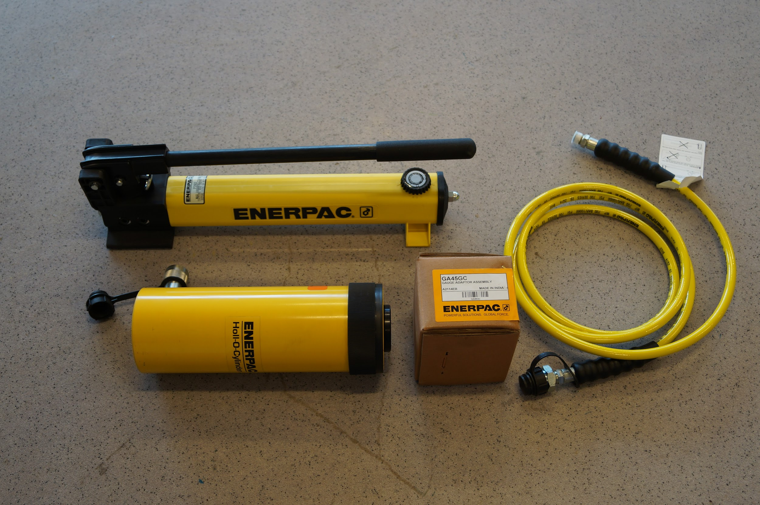

The hydraulic system consists of the original parts from ENERPAC. The cylinder has 30 tons force and has center hole where we have constructed a through bolt (Cylinder Bolt) which can provide an additional force against the kenter-locking bolt with the sledge hammer.

The hydraulic power is coming from a hand-pump which are connected to the Cylinder with a hose with a length of 3 meter.

Maintenance

According to attached manual/schedules from ENERPAC

Sylinder Bolt - (for ENERPAC cylinder)

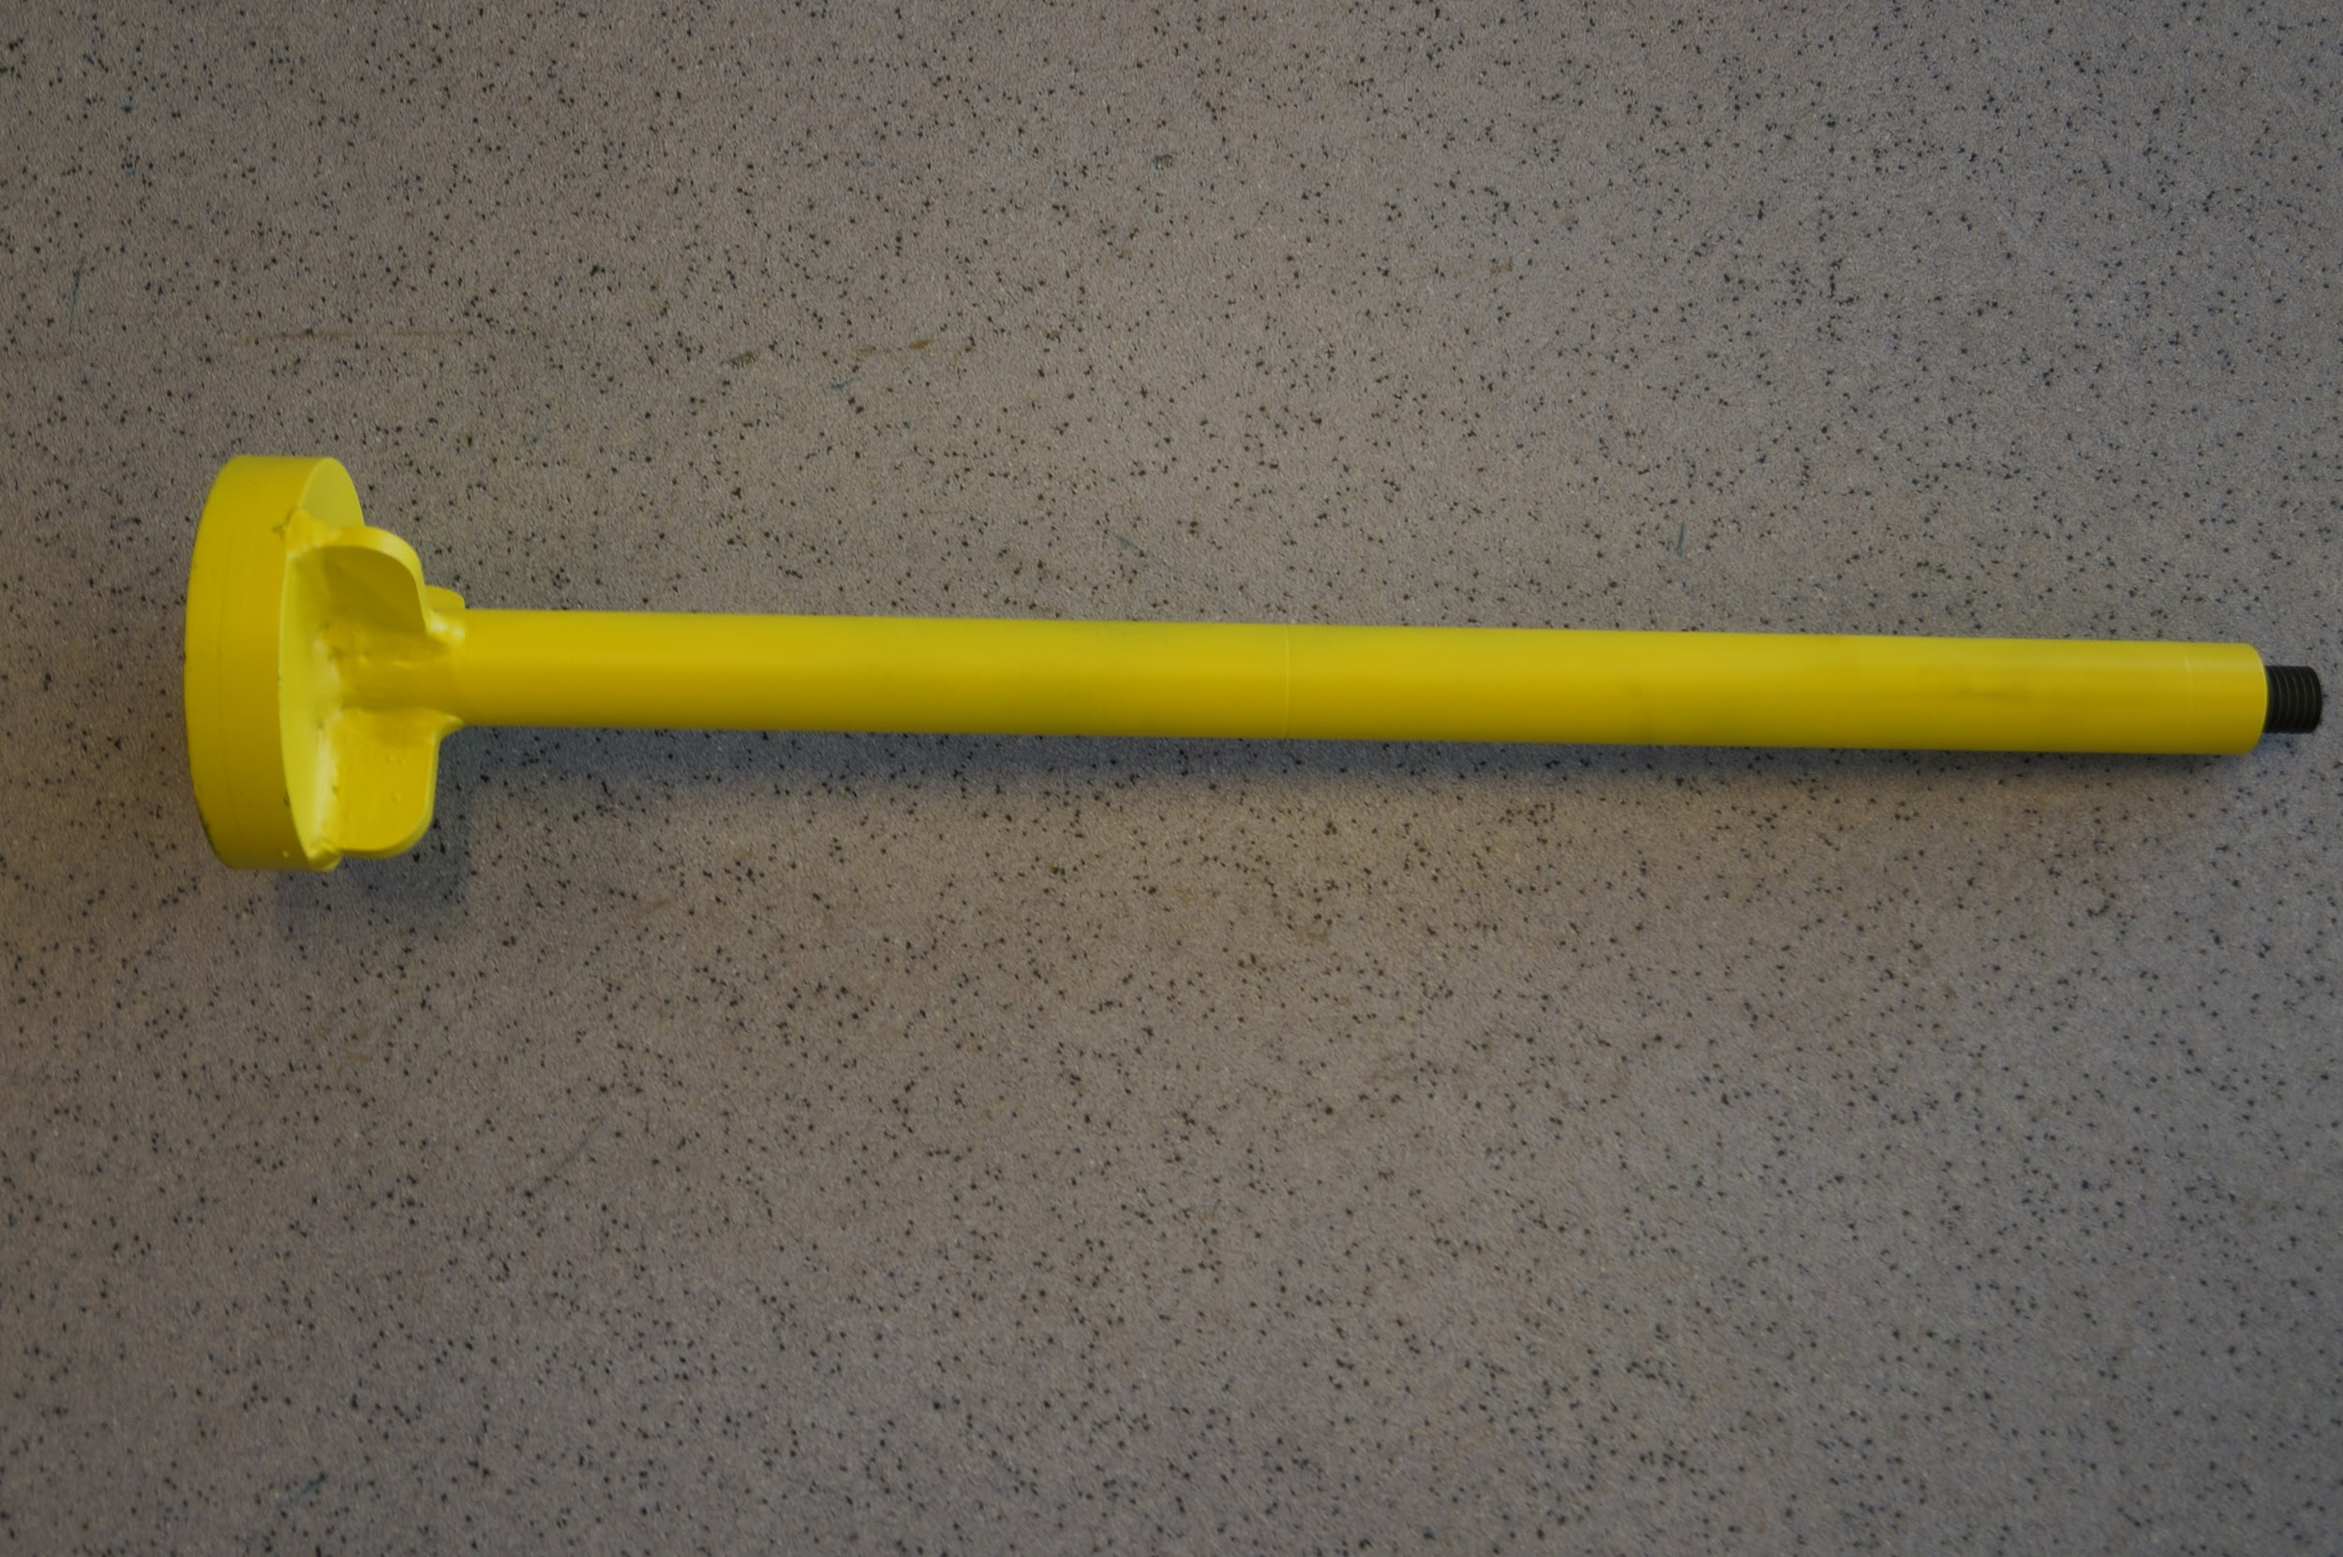

This Cylinders Bolt, that goes thru the ENERPAC -cylinder, has a “back board” intended for use of sledgehammer and shock the pin (kenter locking pin) while pressure from the hydraulic system is working. Article no. CA768402

Adapter

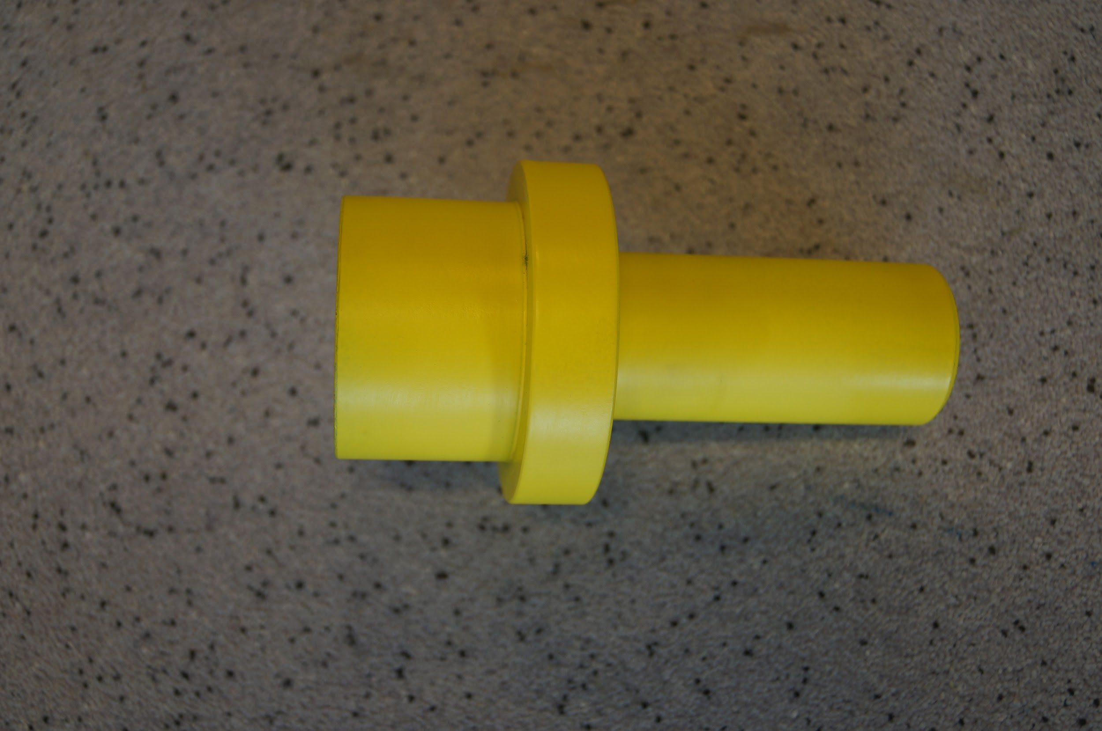

This is the connection between the Cylinder Bolt and the Outward Bolt.
Article no. CA768402

Outward bolt

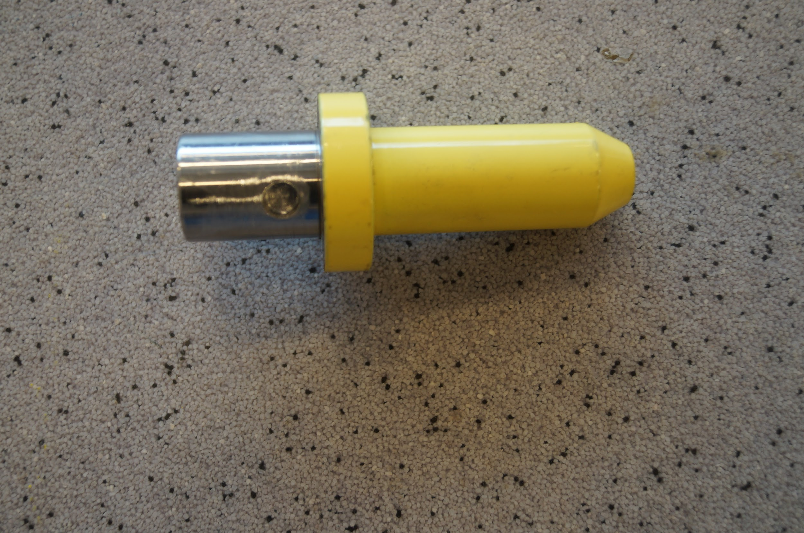
Outward Bolt /pressbolt - to be seated and siting loose in Adapter. DO NOT LOCK THE OUTWARD BOLT IN ADAPTER.

If the Outward Bolt should be sitting tight and locked in Kenter Link - the tool can be dismantled as normal and the Outward Bolt removed with thereafter. (Can happen when Kenter Link is damaged in opening for Locking Pin.)

Cylinder arm - common for 76mm and 84mm brackets

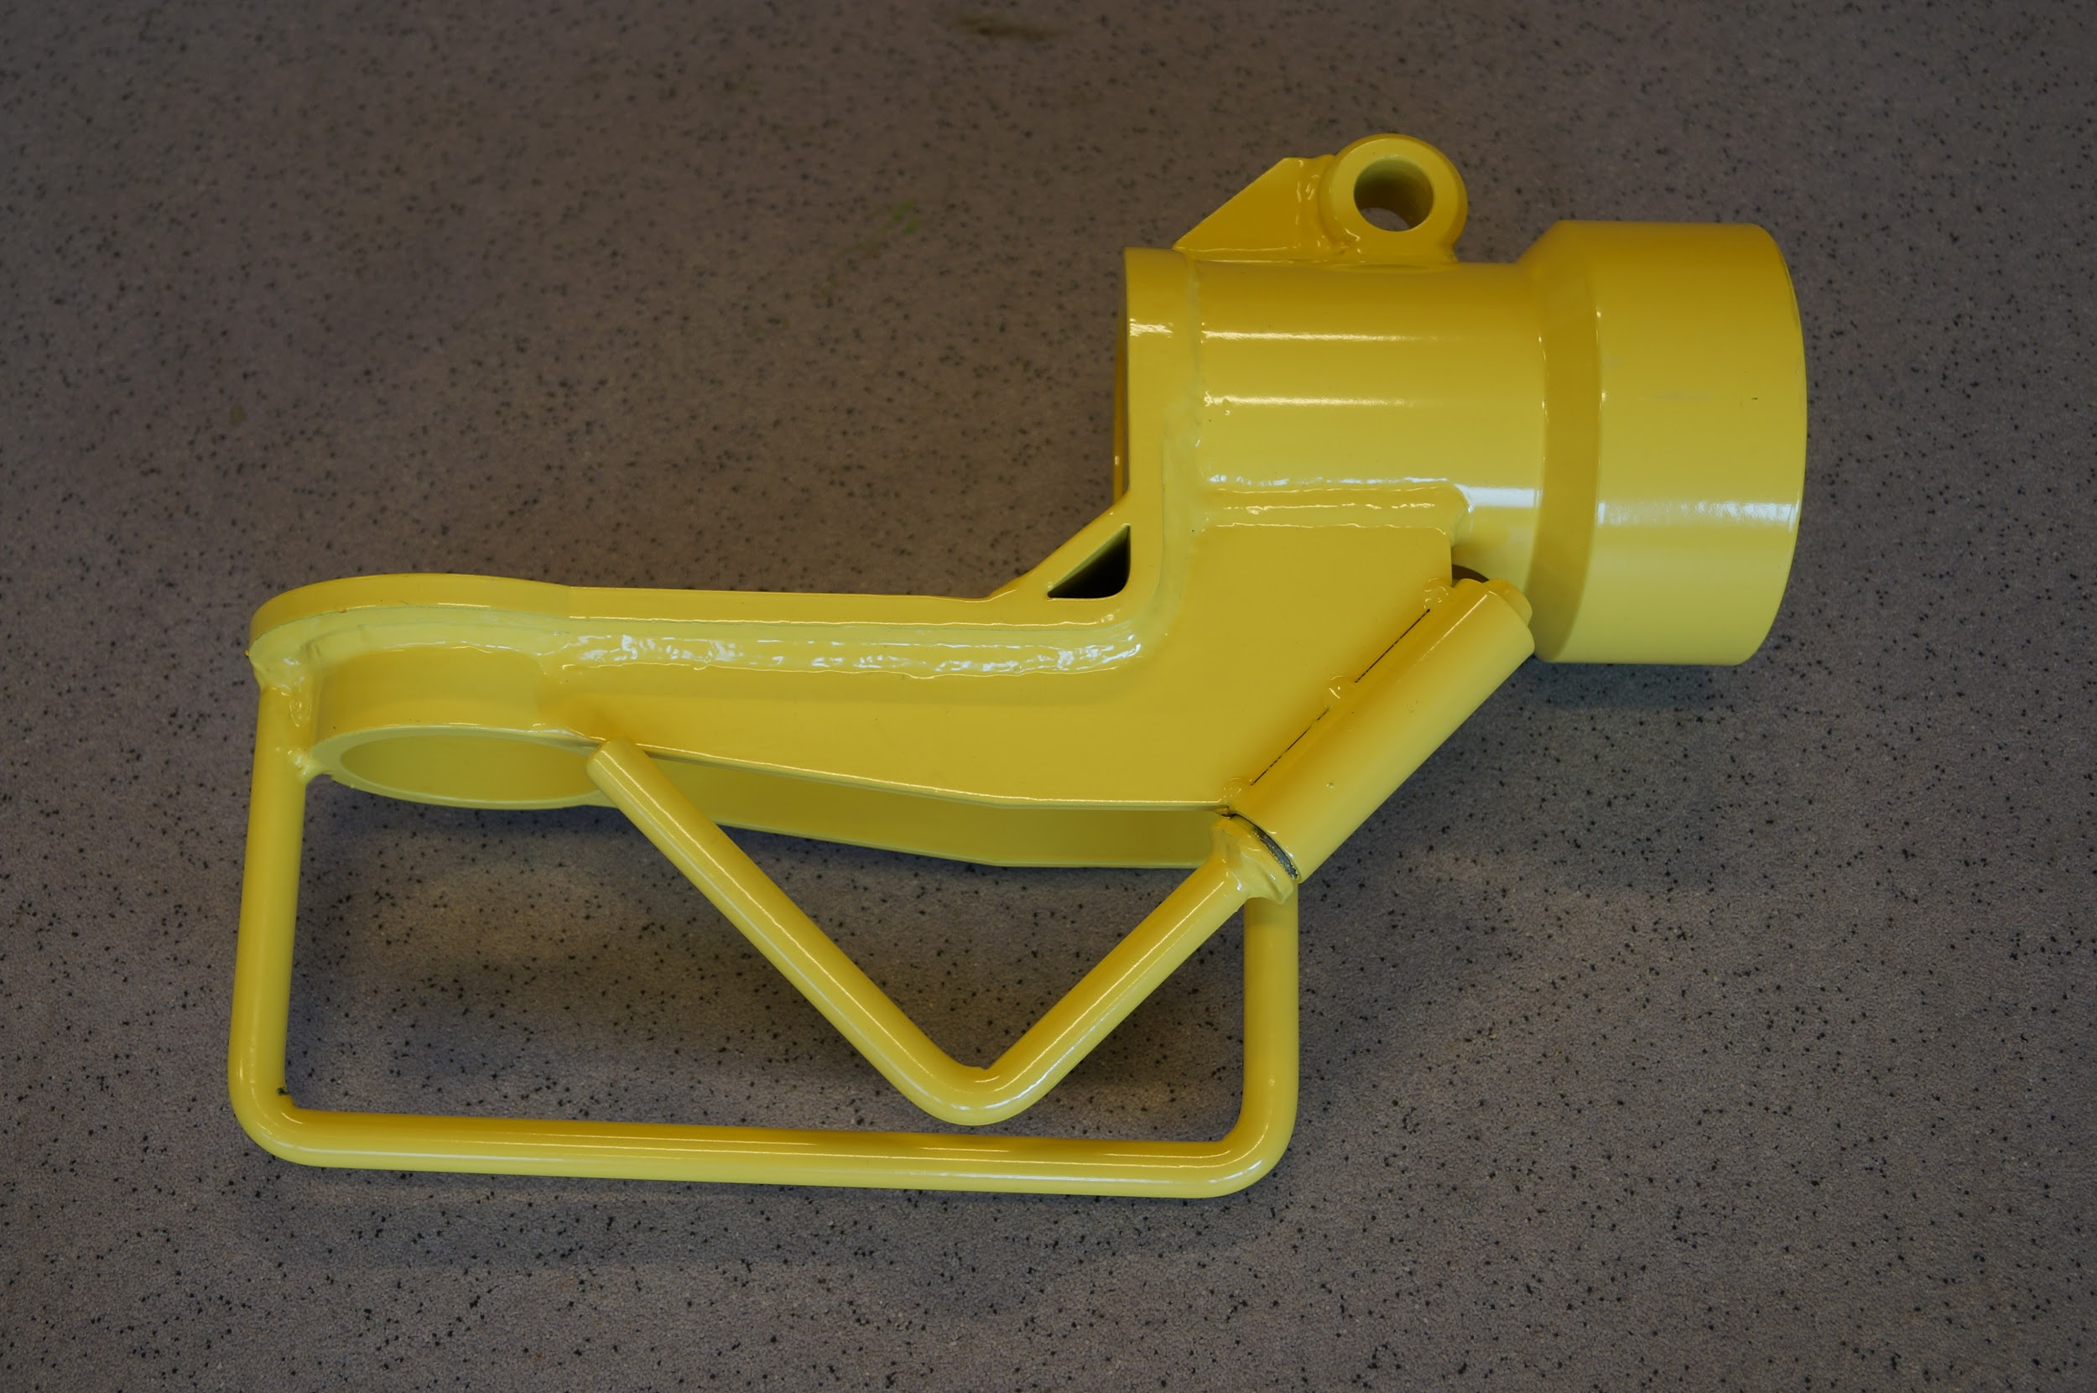

Locking Bolt for the underarm is stored on Cylinder arm.
Article no. CA768400 - Complete cylinder arm.

Bracket for 76mm hydraulic tool

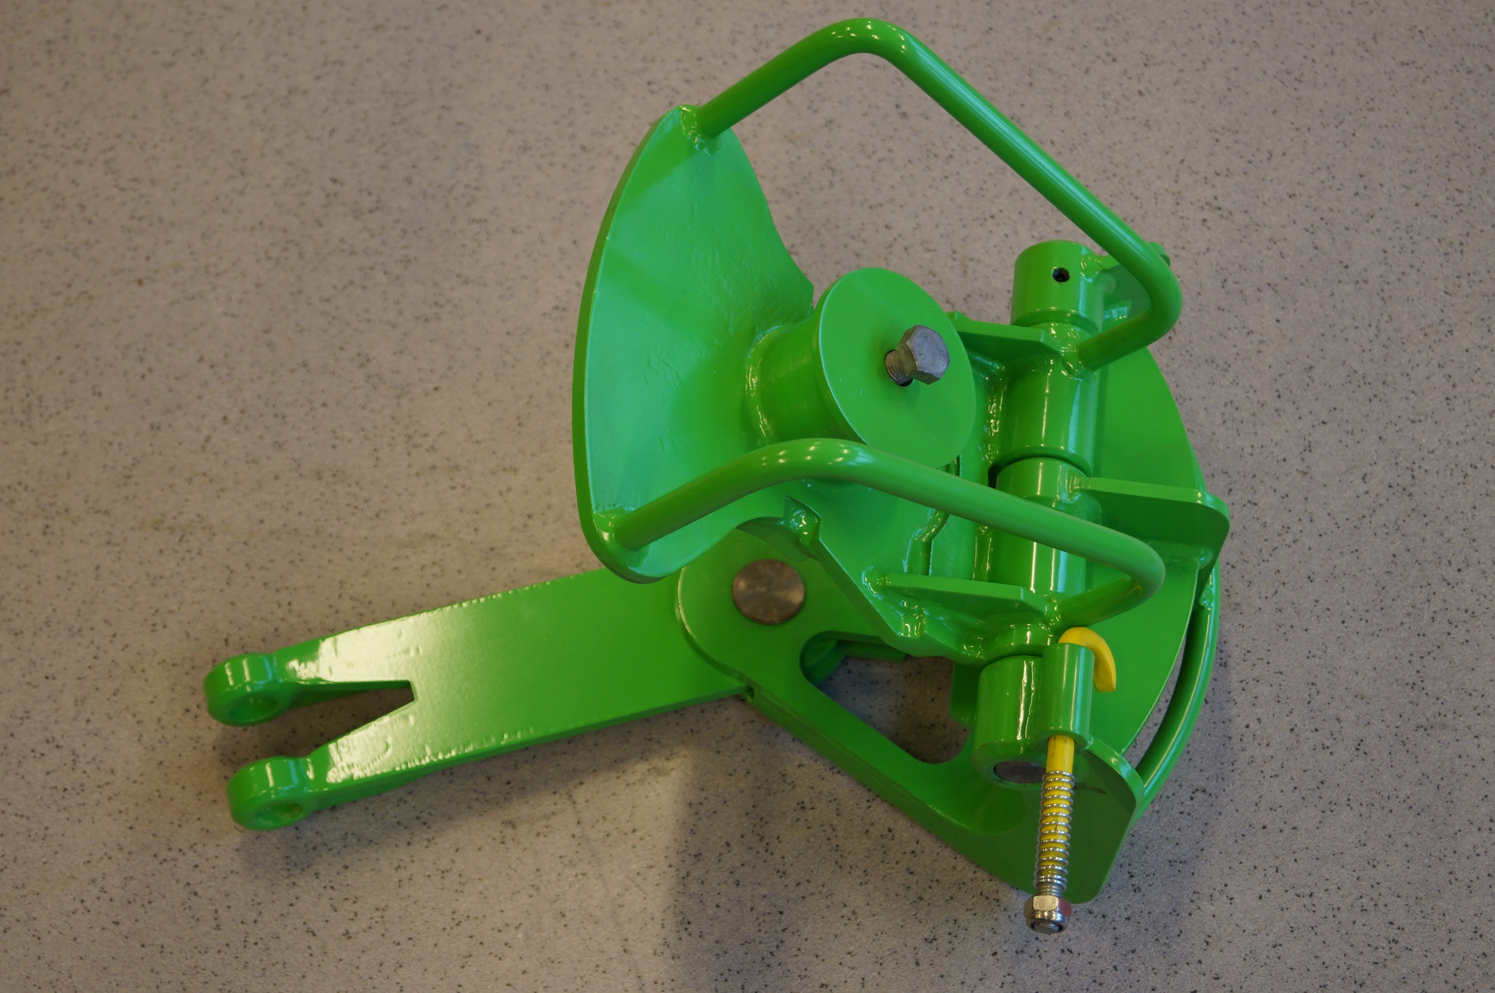
Article no. KL7600 - Complete Bracket 76mm.

Important

The bracket is fitted with a Safety-Pin that must be in locked position when the bracket sits on kenter link/chain. The purpose is to prevent the bracket to open up and fall off while mounting on/off the hydraulic tool/swingarm.

Bracket for 84 mm hydraulic tool

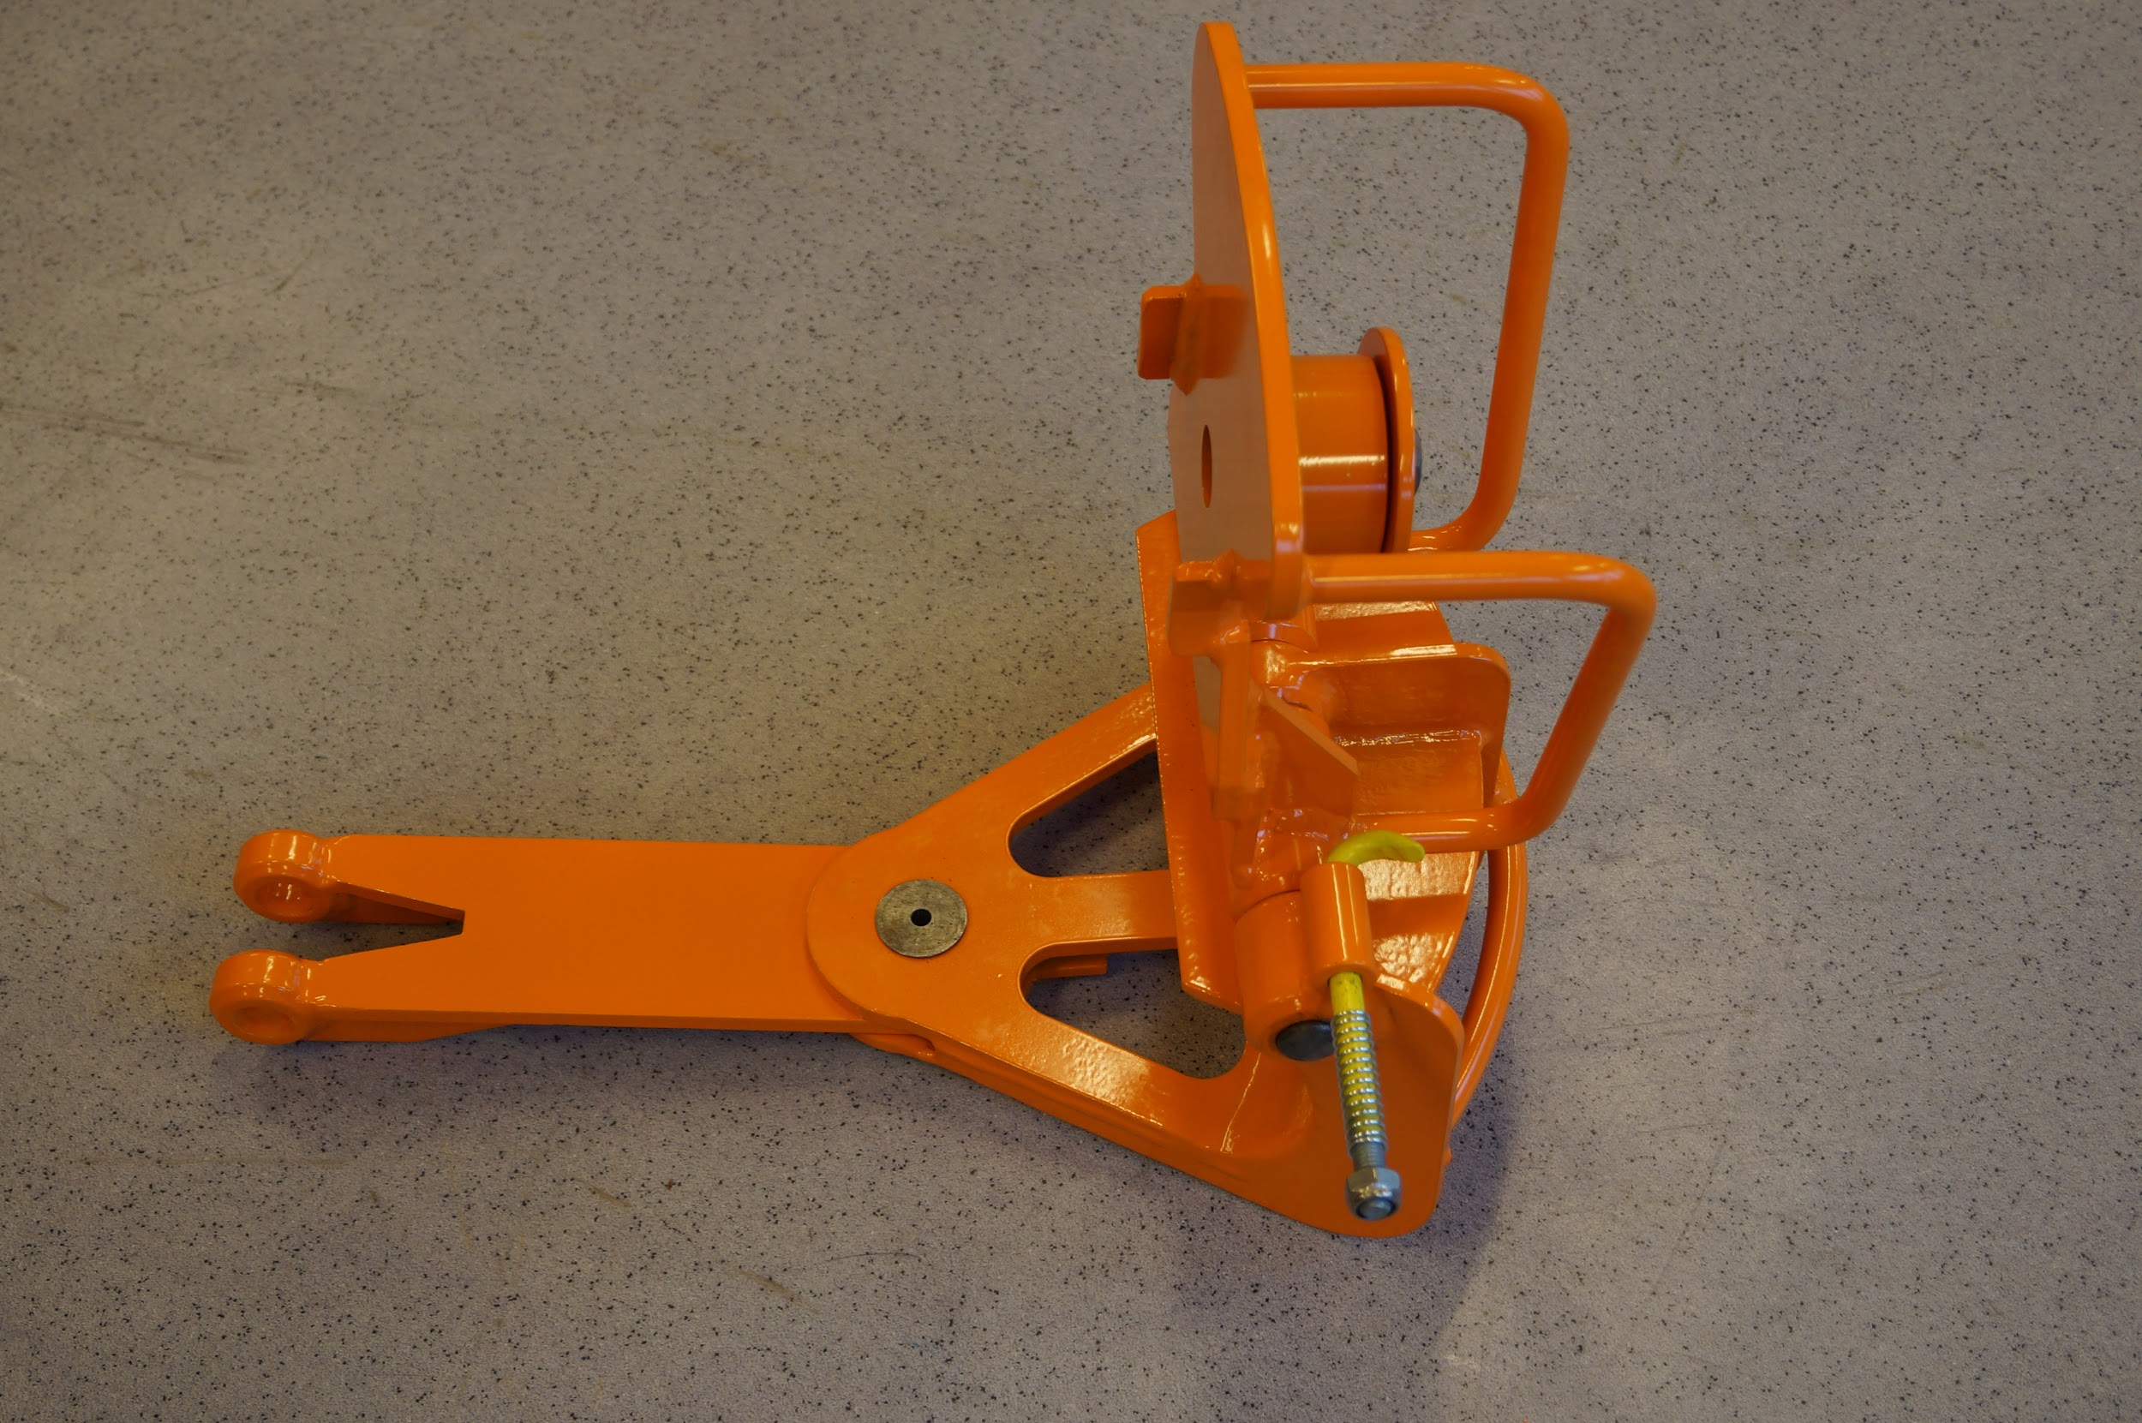
Article no. KL8400 - Complete Bracket 84mm.

Important

The bracket is fitted with a Safety- Pin that must be in locked position when the bracket sits on kenter link/chain. The purpose is to prevent the bracket to open up and fall off while mounting on/off the hydraulic tool/swingarm.

Maintenance of the Brackets

Clean the tool after use.

Check if there are caused distortions or crack damages.

Lubricate Hinges, Safety-Pin and Tap on the Top-plate

Maintenance of the Cylinder arm and bolt system

Clean all equipment after use.

Check if there are caused distortions or crack damages.

Check the Cylinder Bolts “back board” for steel fragments after and before use.

Check the threads on end of Cylinder Bolt (connection to Adapter)

Check threads in Adapter (connection to Cylinder Bolt)

Check Outward bolt - replace/maintain if bended.

Check that Adapter and Cylinder Bolts are screwed all the way in.

Check threads inside of Swing-arm (connection for ENERPAC Cylinder)

How to use the equipment.

Use according to training and manual lifting.

REMEMBER: Always use correct technique when lifting the equipment.

Assembly of 84mm Hydraulic tool and 84mm Punch Device

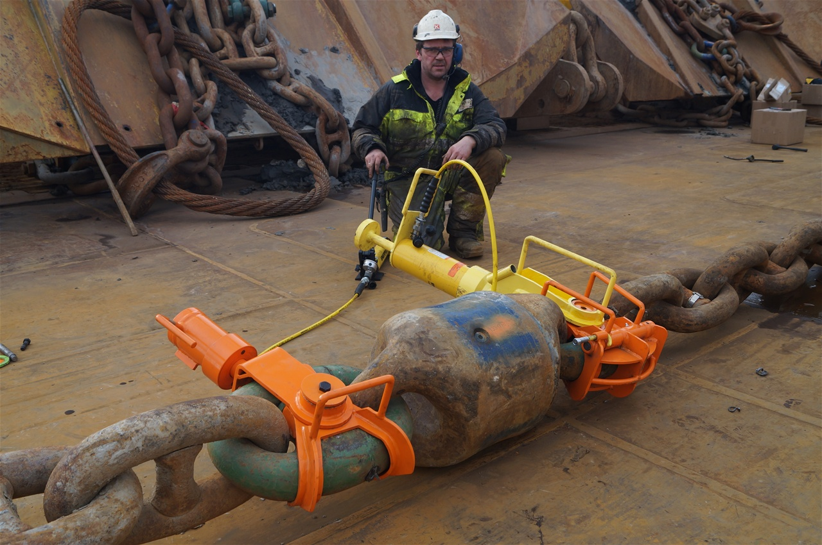

This picture is from the KL Sandefjord and shows a PD84 and Hydraulic tool on each 84mm kenterlink. The color code for 84mm is orange. The yellow cylinder arm is common for 76mm bracket (green color code for 76mm). The color code is replaced with sign/mark as 076 and 084 instead of green and orange colours.

Hydraulic Tool - list of spare parts

Spare part no. | Name | Other
KL7600 | Complete 76mm bracket with Under arm
KL768401 | Under arm (common for 76mm/84mm)
KL7602 | Hinge Bolt
KL7603 | Cover
KL768404 | Bolt for underarm
KL768405 | Securing Pin and Feather
KL768406 | Umbraco for locking hingebolt
KL8400 | Complete 84mm bracket with Under arm
KL8402 | Hingebolt
KL8403 | Cover
CA768400 | Common swing arm for 76mm/84mm brackets
CA768401 | Adapter (common for 76mm/84mm)
CA768402 | Cylinder Bolt
CA768403 | Outward Bolt D24mm L60mm
CA768403-01 | Outward Bolt D22mm L60mm
SM1202-06 | Outward Bolt L52mm x D24mm
CA768404 | Locking Bolt for underarm
CA768405 | ENERPAC 30 tons cylinder
CA768406 | ENERPAC hand pump
CA768407 | ENERPAC manometer
CA768408 | ENERPAC coupling adapter
CA768409 | ENERPAC hose 3 mtr.

Description of the test for the Hydraulic Tool

With reference to the assessment: The test was carried out by Kongsberg Devotek AS - Aalesund/Norway and done onshore in agreement with Statoil. The aim of the test was to check the forces introduced to the tool and evaluate the design versus the loads of this than unknown equipment.

The test should identify weaknesses in the design and evaluate if the weaknesses could be a hazard to the operator, the environment or the equipment.

Based on the evaluation of the prototype tool and test, the tool is capable of handling more than the loads of it intended use. The tool is probably over dimensioned and could be redesigned to reduce the weight for the final design.

Changes in design and construction since testing by a third party.

Changes are done since the testing.The weight is reduced simultaneously as it is supplied reinforcements in the construction. All tests show that construction has adequate strength. The tool has been duly tested offshore onboard “ Havila Mars” and “KL Sandefjord”.

The construction is otherwise of such a type that keeps its strength only if it is used specific for the purpose and dimensions it is built for.

Soft Mandrel and Punch Device

This equipment is not subjected to other forces than provided by the use of a sledgehammer. The “Punch Device” seems to be over dimensioned relative to the loads, but must have some weight to sit comfortably and safely on kenter when it is in use.

What is important for these two types of tool are the contribution within the HSE. Use of this tool leads to less exposure to vibration and meets currents regulations concerning protection against mechanical vibrations.

Picture of the contents of the “North Sea Package” .

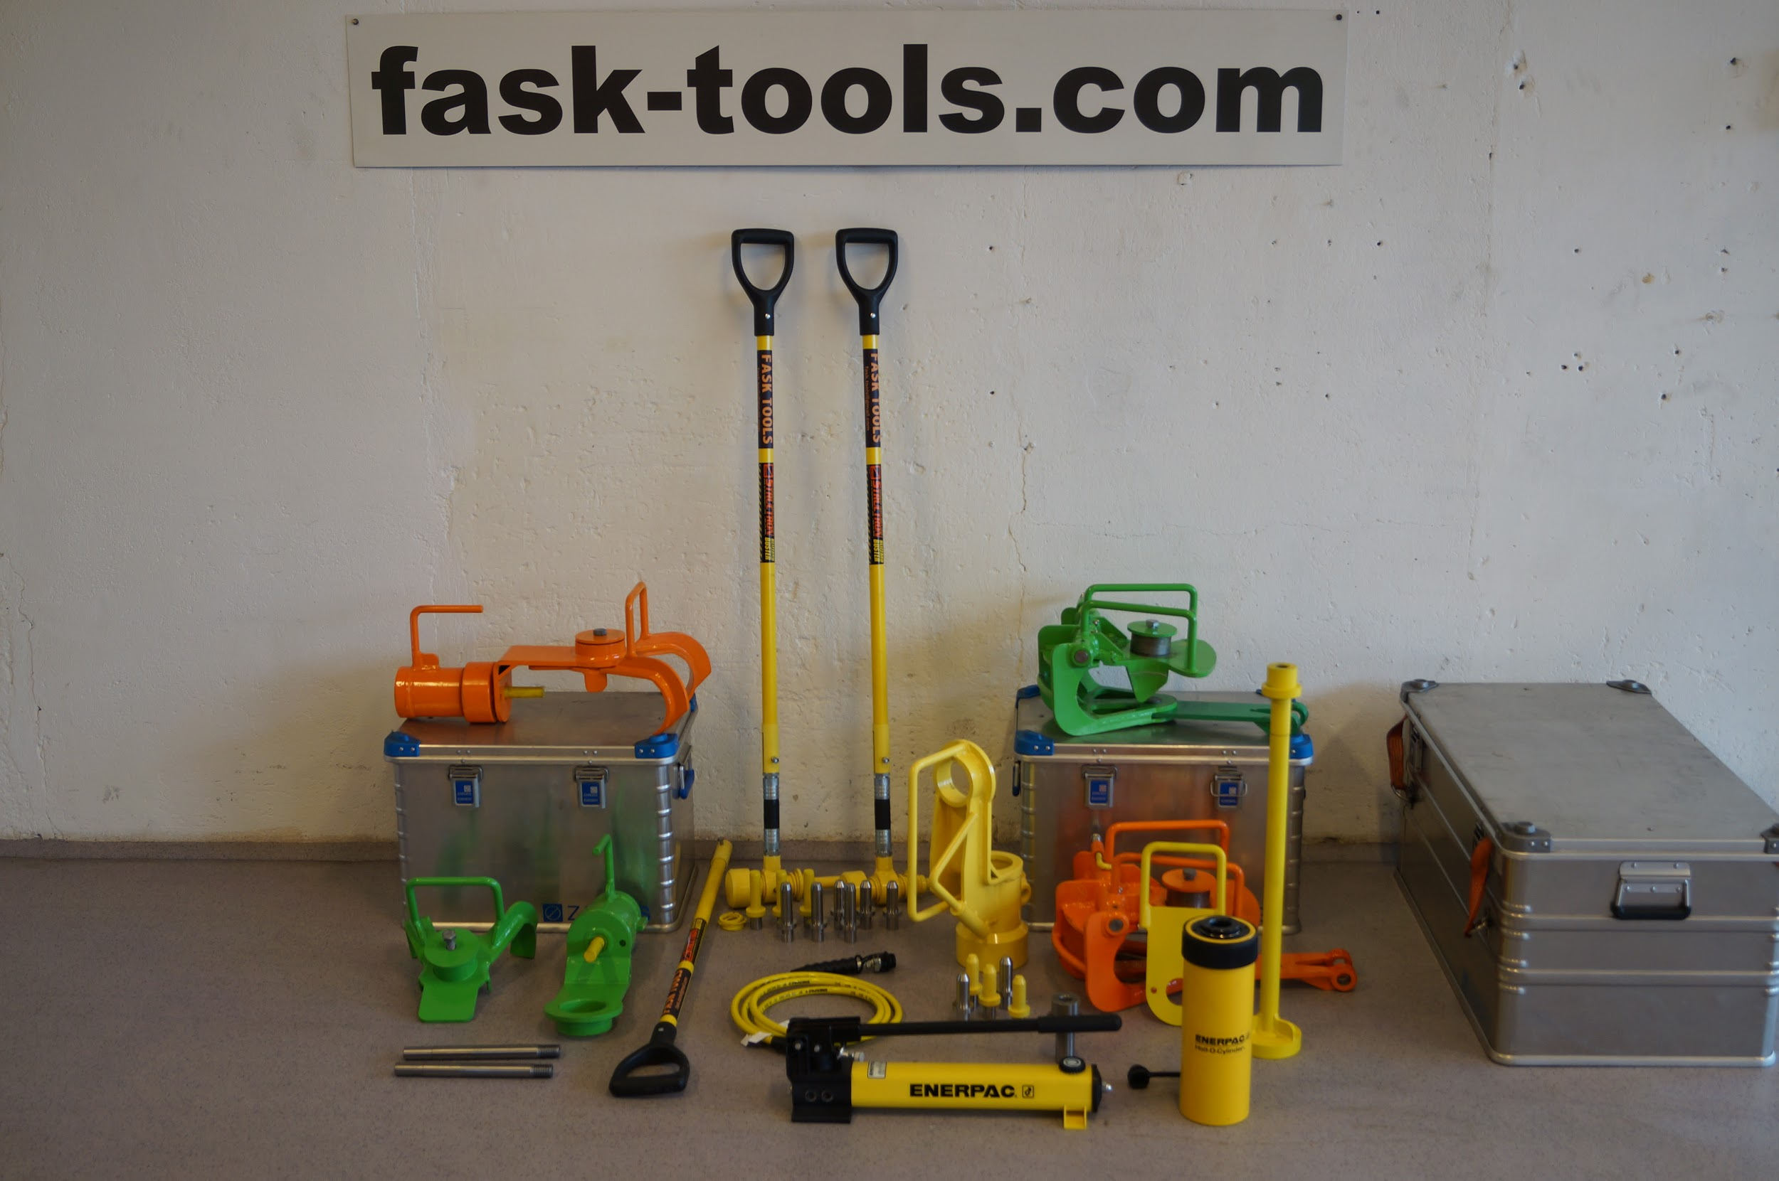

This is the package we recommend all AH-vessels to have onboard. The most safe tools for all phases within opening chain links/kenter links. Important to use the tool rationally, Soft Mandrel may be the most rational when mobilization takes place with lines from quay side coming onboard. However it is more rational to use Punch Device in AH-operation when the line comes up from the sea bed, then the crew can work more independently and safe.

If the kenter link can't be opened with the Punch Device after “<10” punches with sledge hammer, than it is time for the Hydraulic Tool.

Accurate use of the tool enhances to predictability and the crew will learn to know shortly whether it is possible to open the actual kenter link or not.

FASK TOOLS AS
Postboks 306
Hagevegen 2
6151 Ørsta
NORWAY

NO-VAT number : 912 154 602

